

SMART ICU PATIENT MONITORING SYSTEM USING COMPUTER VISION AND DEEP LEARNING

A CAPSTONE PROJECT REPORT

A Capstone Project Report submitted in partial fulfilment of the requirements for the Course of

ITAA0517-COMPUTER VISION

to the award of the degree of

BACHELOR OF ENGINEERING

IN
ARTIFICIAL INTELLIGENCE AND MACHINE LEARNING

Submitted by

Yoga Madha A(192425058)

Under the Supervision of
Dr S CHRISTY

SIMATS ENGINEERING
Saveetha Institute of Medical and Technical Sciences Chennai-602105

SEPTEMBER 2026

SIMATS ENGINEERING
Saveetha Institute of Medical and Technical Sciences Chennai-602105

BONAFIDE CERTIFICATE

This is to certify that the Capstone Project entitled “Smart ICU Patient Monitoring System Using Computer Vision And Deep Learning” has been carried out by Yoga Madha A under the supervision of Dr.S.Christy and is submitted in partial fulfilment of the requirements for the current semester of the B-TECH Artificial Intelligence and Machine Learning program at Saveetha Institute of Medical and Technical Sciences, Chennai.

Course Coordinator Course Faculty
Dr.Carmel Mary Belinda M J Dr.S.Christy
Professor Professor
Dept.Of.CSE Dept.Of.CSE
SIMATS Engineering, SIMATS Engineering,
SIMATS, Chennai – 602105. Simats, Chennai – 602105.

SIMATS ENGINEERING
Saveetha Institute of Medical and Technical Sciences Chennai-602105

DECLARATION

I, YogaMadha(192425058) SIMATS Engineering, Saveetha Institute of Medical and Technical Sciences, Chennai, hereby declare that the Capstone Project Work entitled “Smart ICU Patient Monitoring System Using Computer Vision And Deep Learning” is the result of our own bonafide efforts. To the best of our knowledge, the work presented herein is original, accurate, and has been carried out in accordance with the principles of engineering ethics and academic integrity. All sources, references, data, and other materials used in the project have been appropriately acknowledged. We further declare that the data, results, analysis, and findings presented in this report have not been fabricated, falsified, or manipulated. Any external tools, software, datasets, computational resources, or AI-assisted tools used during the project have been appropriately disclosed. We confirm that all applicable ethical, academic, institutional, and professional requirements have been duly followed throughout the planning, execution, analysis, and documentation of the project.

Place:Chennai
Date:

Signature of the Students with Names
Yoga Madha(192425058)

SIMATS ENGINEERING
Saveetha Institute of Medical and Technical Sciences Chennai-602105

Individual Contribution Statement
Student Name / Register No. | Specific Responsibilities | Design & Development Contribution | Testing & Analysis Contribution | Report Contribution | Approx. Contribution (%)
Yoga Madha A (192425058) | Module 1 – ICU Dashboard & Patient Management | Developed the ICU dashboard interface, patient management features, patient status display, bed occupancy information, and monitoring interface. | Tested dashboard functions, patient/bed status display, navigation, and monitoring information under different test scenarios. | Prepared documentation related to the ICU dashboard, patient management, system interface, and implementation. | 50%
Raja Rajeshwari M (192421253) | Module 2 – AI Computer Vision & Alert Detection | Implemented OpenCV-based video processing, YOLO patient/bed detection, MediaPipe pose analysis, and critical event detection including fall and bed-exit events. | Tested AI detection, patient activity, posture, fall/bed-exit scenarios, and alert generation; analysed the obtained results. | Prepared documentation related to Computer Vision, AI techniques, event detection, testing, and results. | 50%
Total | All Modules | Complete system integration | Complete system testing and validation | Complete project report | 100%

ABSTRACT
Smart Intensive Care Unit (ICU) environments require continuous observation of patients to identify dangerous situations at the earliest possible time. Conventional ICU monitoring mainly depends on healthcare professionals continuously observing patients and manually responding to events such as falls, unexpected bed exits, abnormal movements, and changes in patient condition. This creates a significant workload and may result in delayed detection when multiple patients require attention simultaneously. Therefore, an automated Computer Vision-based monitoring system can provide valuable assistance by continuously analyzing patient activity.
The proposed Smart ICU Patient Monitoring System is an AI-enabled monitoring platform that uses camera-based video analysis to observe patients in real time. The system combines OpenCV, YOLO, and MediaPipe to perform different monitoring tasks. OpenCV is used for video capture and frame processing, while YOLO is applied for patient and bed detection and occupancy monitoring. MediaPipe Pose is used to analyze body posture and movement. The processed information is evaluated to identify events such as potential falls, bed-exit attempts, abnormal activities, and other critical situations.
When a critical event is detected, the system generates an immediate alert and captures relevant visual evidence. The event information and screenshots can be stored using Firebase, allowing healthcare staff to review previous alerts. A web-based dashboard provides an organized interface for viewing patient status, bed occupancy, live camera feeds, detection results, and alert history. The system can also process uploaded images or videos in addition to live camera input.
The developed prototype demonstrates that Computer Vision can support continuous ICU observation and reduce dependence on constant manual video monitoring. It provides faster identification of potentially dangerous events and maintains a record of detected incidents for later analysis. The system is intended as an assistive healthcare solution, supporting doctors and nurses rather than replacing professional medical judgment. Overall, the proposed system demonstrates the practical use of AI and Computer Vision for improving patient safety and monitoring efficiency in ICU environments.
Keywords
Computer Vision, Smart ICU, YOLO, MediaPipe, Patient Monitoring, Fall Detection

TABLE OF CONTENTS

Sl.No | Title | Page  No
i | CERTIFICATE FROM THE SUPERVISOR | ii
ii | DECLARATION BY THE CANDIDATE | iii
Iii | INDIVIDUAL CONTRIBUTION STATEMENT | iv
iv | ABSTRACT | v
v | LIST OF FIGURES | vi
vi | LIST OF TABLES | vii
1 | CHAPTER 1: Introduction | 9-12
2 | CHAPTER 2: Literature Review | 13-16
3 | CHAPTER 3: Engineering Design & Trade-offs, Sustainability,  Ethics, Safety, Risk & Security | 17-21
4 | CHAPTER 4: Implementation, Testing & Results, Project  Management | 22-26
5 | CHAPTER 5: Conclusion & Reflection | 27-28
 | References | 29
 | Appendices | 30-34

LIST OF FIGURES

Figure No. | Figure Name | Page No.
1 | Login Page | 23
2 | Smart ICU Main Monitoring Dashboard | 23
3 | AI-Based Patient and Activity Detection Results | 23

LIST OF TABLES
Table  No. | Table Name | Page  No.
1 | Comparative Analysis | 14
2 | Stakeholder / User Requirements | 16
3 | Functional & Non-Functional Requirements | 16
4 | Project Constraints | 17
5 | Applicable Standards / Codes | 18
6 | Design Specifications | 18
7 | Evaluation Matrix | 19
8 | Trade-off Analysis | 20
9 | Sustainability, Ethics, Safety, Risk & Security | 20
10 | Risk Register | 20
11 | Test Plan & Verification | 23
12 | Main Test Results | 24
13 | Achievement of Objectives | 25
14 | Project Milestones | 26
15 | Roles & Contribution | 26
16 | Project Budget | 26

CHAPTER 1

INTRODUCTION AND ENGINEERING PROBLEM

1.1 Background
Intensive Care Units (ICUs) require continuous monitoring because patients may experience sudden movements, falls, bed-exit attempts, or other unexpected situations. Conventional monitoring mainly depends on nurses and doctors observing patients through direct supervision or CCTV cameras. Although CCTV provides continuous video, it does not automatically understand the activities taking place in the scene.
Computer Vision provides a way to automatically analyze video and identify important patient activities. In this project, OpenCV is used for video processing, YOLO is used for patient and bed detection, and MediaPipe Pose is used for body posture and movement analysis. The system combines these technologies to create an intelligent monitoring solution.
The proposed system also uses Firebase for storing detected events, screenshots, and alert information. A web dashboard provides healthcare staff with an easy interface to monitor patient status and critical events.
1.2 Need for the Project
ICU patients require continuous and careful observation.
Healthcare staff may need to monitor multiple patients simultaneously.
Falls and unexpected bed-exit attempts can occur without warning.
Manual monitoring increases the workload of nurses and healthcare professionals.
Conventional CCTV systems mainly provide video recording without intelligent event detection.
A Computer Vision system can automatically analyze video and identify potentially critical events.
Real-time alerts can help healthcare staff become aware of important events more quickly.
The project has engineering significance because it combines AI, Computer Vision, real-time processing, cloud storage, and web technology into one monitoring system.
1.3 Problem Statement
The engineering problem is to develop a real-time Computer Vision-based ICU monitoring system that can analyze patient video, detect the patient and bed, understand patient posture and movement, and identify potentially critical events such as falls and bed-exit attempts.
The system must operate under practical constraints such as:
Variation in lighting and camera position.
Different patient postures and movements.
Real-time processing requirements.
Detection accuracy and false alerts.
Multiple monitoring activities.
Reliable storage and retrieval of event information.
Patient privacy and secure access.
Limited computing and network resources.
The system must balance accuracy, processing speed, reliability, usability, and safety.
1.4 Project Aim
To design and develop an AI-based Smart ICU Patient Monitoring System using Computer Vision and Deep Learning for real-time patient activity monitoring and critical event alert generation.
1.5 Project Objectives
To design a Computer Vision-based architecture for ICU patient monitoring.
To develop a YOLO-based patient and bed detection module.
To implement MediaPipe-based posture and movement analysis.
To detect potentially critical events such as falls and bed-exit attempts.
To integrate real-time alerts and event screenshot capture.
To store monitoring events using Firebase.
To develop a web dashboard for displaying patient status and alerts.
To test and evaluate the system under different monitoring conditions.
1.6 Scope
Included
Real-time camera/video monitoring.
Patient detection using YOLO.
Bed detection and occupancy monitoring.
Body-pose analysis using MediaPipe.
Potential fall detection.
Bed-exit and activity monitoring.
Critical event alerts.
Screenshot capture.
Firebase-based event storage.
Web-based monitoring dashboard.
Alert history and event review.
Excluded
Diagnosis of medical diseases.
Automatic medical treatment decisions.
Replacement of doctors or nurses.
Direct measurement of medical parameters unless connected to dedicated medical sensors.
Fully autonomous emergency medical intervention.
Assumptions
A camera is available for monitoring.
The camera provides a sufficiently clear view of the patient and bed.
The system has suitable computing resources for video processing.
Firebase/network connectivity is available for cloud-based features.
The monitoring environment is reasonably suitable for Computer Vision detection.
Boundary Conditions
Performance may vary with lighting and camera angle.
Occlusion of the patient may affect detection.
Detection accuracy depends on the training data and model.
The prototype is intended primarily for controlled or simulated ICU environments.
1.7 Expected Engineering Outcome
The expected outcome is a working prototype of a Smart ICU Patient Monitoring System consisting of:
Computer Vision monitoring module
YOLO-based patient and bed detection
MediaPipe-based posture analysis
Fall and bed-exit event detection
Real-time alert mechanism
Firebase event and screenshot storage
Web-based monitoring dashboard
Patient event history
The final prototype is expected to demonstrate how AI and Computer Vision can be integrated into healthcare monitoring to provide continuous observation, faster event awareness, and improved patient safety support.

CHAPTER 2
LITERATURE REVIEW AND EXISTING SOLUTIONS
2.1 Review Method
- Relevant research papers were identified from IEEE, ScienceDirect, PubMed, MDPI, and other scholarly sources.
- The review focused on Computer Vision, patient monitoring, fall detection, pose estimation, and Deep Learning.
- Recent studies using CNN, YOLO, pose estimation, and real-time video analysis were considered.
- Existing approaches were compared based on accuracy, real-time performance, detection capability, and practical limitations.
- Research gaps were identified to develop a more integrated ICU monitoring solution.
2.2 Review of Existing Work
1. Vision-Based Fall Detection
- Vision-based systems use cameras to detect human falls without requiring wearable sensors.
- Deep Learning has improved automatic feature extraction and fall classification.
- However, many systems mainly focus on fall detection alone.
2. Deep Learning-Based Monitoring
- CNN and other Deep Learning methods are widely used for human activity and fall recognition.
- These methods can achieve good detection performance.
- A major challenge is maintaining performance in different environments and real-time conditions.
3. Pose-Based Detection
- Human pose estimation can identify body landmarks and analyze posture.
- It can help distinguish normal activities from potentially dangerous movements.
- Pose-based approaches are useful for fall and activity analysis.
4. Recent Real-Time Systems
- Recent research has focused on deploying vision-based fall detection on real-time and edge platforms.
- However, studies still report limited real-world testing, controlled datasets, and hardware-dependent performance.
2.3 Comparative Analysis
Existing Approach | Advantages | Limitations | Relevance to Proposed Work
Manual ICU Monitoring | Direct human observation | High workload; events may be missed | System provides automated assistance
CCTV Monitoring | Continuous video recording | Does not automatically understand events | Proposed system performs video analysis
Sensor-Based Monitoring | Can detect specific patient conditions | Wearable sensors may be uncomfortable | Proposed system uses non-contact monitoring
Vision-Based Fall Detection | Non-contact and automatic | Often focuses mainly on falls | Extended to multiple ICU events
Pose-Based Monitoring | Useful for posture and movement analysis | Sensitive to occlusion and camera position | Used for patient activity analysis
Proposed System | Combines detection, pose, alerts and cloud storage | Prototype and dataset dependent | Provides an integrated ICU monitoring platform
Vision-based fall detection research shows strong potential, but practical deployment remains challenging because of factors such as occlusion, lighting, camera placement, dataset quality, and real-time performance.
2.4 Research / Engineering Gap
The major gaps identified are:
- Many existing systems focus mainly on fall detection.
- Patient and bed monitoring are not always integrated with activity analysis.
- Some systems are tested using small or controlled datasets.
- Real-world ICU environments introduce lighting, occlusion, and camera-position challenges.
- Real-time performance and hardware requirements are not consistently reported.
- Alert generation and event history are not always included in the Computer Vision pipeline.
- There is a need for a simple integrated monitoring platform connecting Computer Vision with cloud storage and a web dashboard.
2.5 Proposed Contribution
The proposed project addresses these gaps by:
- Combining YOLO and MediaPipe in one monitoring system.
- Detecting both patient and ICU bed.
- Monitoring bed occupancy and patient activity.
- Detecting potentially critical events such as falls and bed-exit attempts.
- Generating real-time alerts.
- Capturing screenshots of detected events.
- Using Firebase for event and screenshot storage.
- Providing a web-based ICU dashboard.
- Creating an integrated pipeline from camera input → AI analysis → alert → cloud storage → dashboard.
- Providing an assistive solution designed specifically for ICU monitoring scenarios.

CHAPTER 3
ENGINEERING DESIGN & TRADE-OFFS, SUSTAINABILITY, ETHICS, SAFETY, RISK & SECURITY
3.1 Requirements
Stakeholder / User Requirements
Stakeholder / User | Requirement
Doctors | View patient status and critical alerts quickly.
Nurses | Monitor live video and receive fall/bed-exit alerts.
Hospital Admin | Manage users and review monitoring history.
Patients | Receive non-contact monitoring with appropriate privacy protection.
Functional & Non-Functional Requirements
Requirement Type | Measurable Target
Functional | Detect patient and bed from camera input.
Functional | Identify bed occupancy status.
Functional | Detect potential falls and bed-exit events.
Functional | Generate alerts for critical events.
Functional | Store event details and screenshots in Firebase.
Functional | Display monitoring information through a web dashboard.
Non-Functional | Process video with minimal delay for near real-time monitoring.
Non-Functional | Provide authenticated access to the monitoring dashboard.
Non-Functional | Maintain reliable event storage and retrieval.
Non-Functional | Provide understandable alerts for healthcare staff.
3.2 Constraints & Applicable Standards
Project Constraints
- Technical: Detection performance depends on camera position, lighting, video quality, and computing resources.
- Economic: The prototype should use commonly available hardware and software.
- Privacy: Patient video and event information must be protected from unauthorized access.
- Health & Safety: The system should assist healthcare staff and must not independently make medical decisions.
- Ethical: The system should minimize unnecessary collection and storage of patient information.
Applicable Standards
Standard / Code | Requirement | How Applied in This Project
ISO 14971:2019 | Risk management for medical devices | Used as guidance for identifying and reducing risks related to system alerts and incorrect detection.
IEC 62304:2006+A1:2015 | Software life-cycle processes for medical software | Used as guidance for structured software development, testing, and documentation.
ISO/IEC 27001:2022 | Information security management | Applied conceptually to access control, authentication, and protection of stored data.
IEEE 29148:2018 | Requirements engineering | Used as guidance for defining clear functional and non-functional requirements.
3.3 Design Specifications
Parameter | Target / Requirement | Unit | Priority
Patient Detection | Reliable detection in test environment | % | High
Bed Detection | Correct bed occupancy identification | % | High
Fall Detection | Detect potential fall events | % | High
Processing Speed | Near real-time video processing | FPS | High
Alert Response | Generate alert with minimal delay | Seconds | High
Dashboard | Display live monitoring information | — | Medium
Data Storage | Store events and screenshots reliably | — | High
Authentication | Authorized users only | — | High
3.4 Alternative Solutions & Evaluation
Alternative 1: Sensor-Based Monitoring
Uses wearable or bed-mounted sensors to monitor patient movement and bed occupancy. It can provide direct measurements but requires additional hardware and patient interaction.
Alternative 2: Camera-Based Computer Vision
Uses a camera with AI models to detect patients, beds, posture, and critical movements. It provides non-contact monitoring using a single visual input.
Alternative 3: Hybrid Sensor + Camera System
Combines Computer Vision with physical sensors for additional monitoring information. It can improve event confirmation but increases system complexity and cost.
Evaluation Matrix
Score: 1 = Poor, 5 = Excellent
Criterion | Weight | Sensor-Based | Camera-Based | Hybrid
Performance | 30% | 4 | 4 | 5
Cost | 20% | 3 | 5 | 2
Safety | 20% | 4 | 4 | 5
Sustainability | 10% | 3 | 5 | 3
Reliability | 20% | 4 | 4 | 5
Weighted Score | 100% | 3.7 | 4.4 | 4.1
3.5 Selected Design & Detailed Design
Final Design Selection
The Camera-Based Computer Vision approach was selected because it provides a strong balance of performance, cost, safety, sustainability, and reliability. It achieved the highest weighted score of 4.4/5 in the evaluation matrix.
System Architecture
CAMERA / VIDEO
↓
OpenCV
↓
┌────────┴────────┐
↓ ↓
YOLO MediaPipe
↓ ↓
Patient & Bed Body Pose
Detection Analysis
└────────┬────────┘
↓
Event Analysis
↓
Normal / Critical
↓
┌────────┴────────┐
↓ ↓
Dashboard Alert
↓
Firebase
↓
Event History
Essential Engineering Calculation
For real-time monitoring, processing performance can be represented by:
FPS = Number of processed frames / Processing time
For example, if 150 frames are processed in 5 seconds:
FPS = 150 / 5 = 30 FPS
A higher FPS provides smoother real-time monitoring.
Systems Approach
- The camera provides video input to the OpenCV processing module.
- YOLO and MediaPipe independently analyze different aspects of the same video.
- Their outputs are combined by the event analysis module.
- Critical events are sent to the alert system and Firebase, while the dashboard displays the monitoring results.
3.6 Trade-Off Analysis
Design Decision | Alternative Considered | Benefit | Disadvantage | Final Decision & Justification
Camera-based monitoring | Wearable sensors | Non-contact and easier to deploy | Affected by camera view and lighting | Selected because it provides multi-event monitoring without wearable devices.
YOLO detection | Traditional image processing | Better object detection capability | Requires trained model and computing resources | Selected for reliable patient/bed detection.
MediaPipe Pose | Basic motion detection | Provides body landmark information | Can be affected by occlusion | Selected for posture and movement analysis.
Firebase storage | Local-only storage | Cloud access and event history | Requires network connectivity | Selected for centralized event storage and dashboard integration.
3.7 Sustainability, Ethics, Safety, Risk & Security
Domain | Consideration | Evidence Evaluated | Impact on Final Decision
Sustainability | Reduce additional hardware requirements | Camera-based system avoids multiple wearable sensors | Selected a software-focused approach with limited additional hardware.
Ethics | Patient privacy and responsible AI | Video contains sensitive patient information | Authentication and controlled data access were included.
Health & Safety | Incorrect alerts may affect response | False positives/negatives are possible | System is designed as an assistive tool, not an autonomous medical decision-maker.
Security | Protection of patient/event data | Firebase stores monitoring information | Authentication and database access controls are required.
Risk Register
Risk | Likelihood | Severity | Risk Level | Mitigation | Residual Risk
False fall detection | Medium | High | High | Improve training data and test different movements | Medium
Missed fall detection | Low/Medium | High | High | Test multiple postures, camera angles and scenarios | Medium
Poor lighting | Medium | Medium | Medium | Use suitable lighting and image preprocessing | Low
Patient occlusion | Medium | Medium | Medium | Improve camera placement and model testing | Medium
Network failure | Medium | Medium | Medium | Maintain local event handling and retry storage | Low
Unauthorized dashboard access | Low | High | High | Authentication and Firebase security rules | Low
Camera failure | Low | High | Medium | Monitor camera connection and provide system status | Low
Incorrect AI interpretation | Medium | High | High | Human verification and clear system limitations | Medium

CHAPTER 4
IMPLEMENTATION, TESTING & RESULTS, PROJECT MANAGEMENT
4.1 Development Approach & Resources
The project was developed using a modular Computer Vision approach. The system was divided into patient and bed detection, pose and event detection, and alert/dashboard modules. YOLO and MediaPipe were integrated with OpenCV for processing live or recorded video. Firebase was used for storing event information and screenshots, while the web dashboard was used to display monitoring results.
Resources Used
Resource | Purpose
Camera / Video | Patient monitoring input
Computer / Laptop | Model execution and development
Patient images/videos | Testing and validation
Firebase | Event and screenshot storage
Python | System development
4.2 Hardware / Software / Implementation & Modern Tools Used
Hardware
- Laptop/PC – Development and model execution.
- Camera – Live patient video input.
Software
Tool / Software | Purpose | Stage Used
Python | Main system development | Development
OpenCV | Video and image processing | Implementation
YOLO | Patient and bed detection | Detection
MediaPipe | Pose and movement analysis | Event Detection
Firebase | Cloud data and screenshot storage | Deployment
VS Code | Coding and project management | Development
Web Browser | ICU monitoring dashboard | Testing/Demo
Implementation
- Camera captures the patient video.
- OpenCV reads and processes video frames.
- YOLO detects the patient and bed.
- MediaPipe identifies body landmarks.
- Event analysis determines normal or critical activity.
- Critical events generate alerts.
- Screenshots and event details are stored in Firebase.
- Results are displayed on the web dashboard.
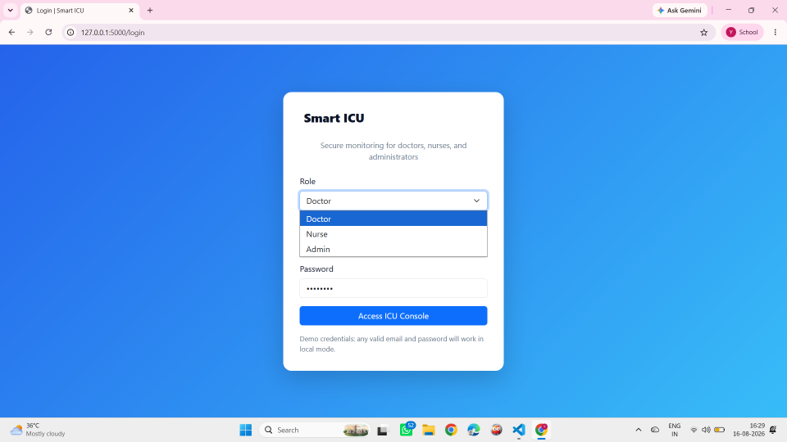
Figure 1 – Login Page4.3 Test Plan & Verification
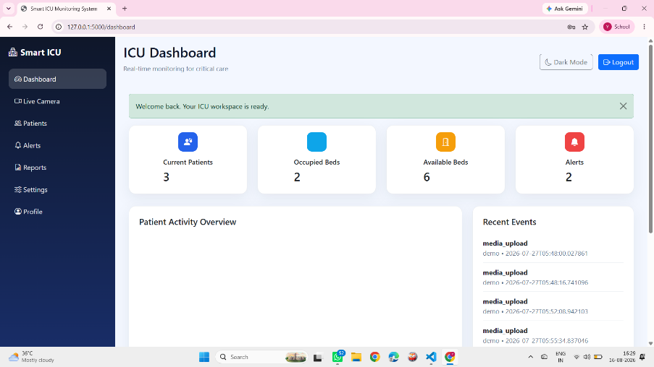
Figure 4.2: Smart ICU Main Monitoring Dashboard
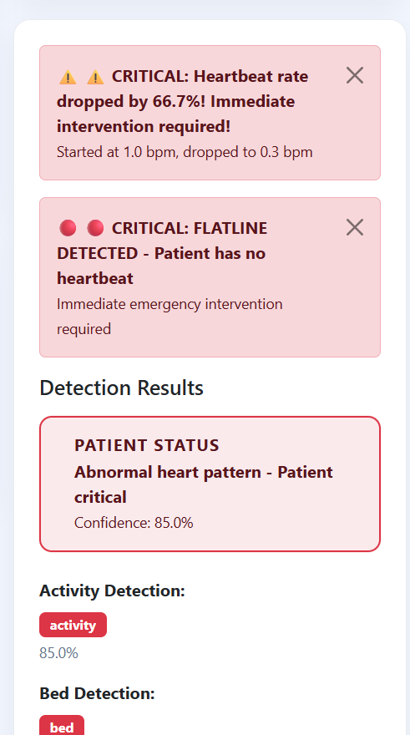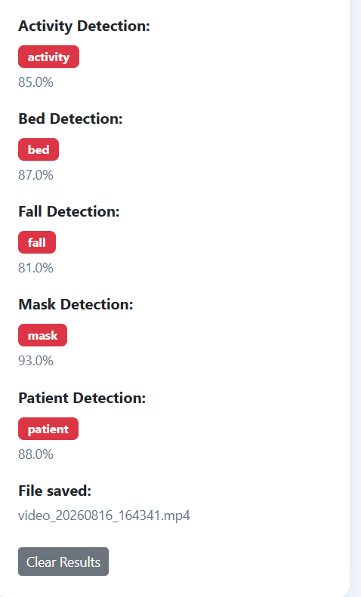
Figure 4.4: AI-Based Patient and Activity Detection Results
4.4 Results
The prototype was tested using different patient monitoring scenarios.
Main Test Results
Test Scenario | Expected Result | Actual Result | Status
Patient on bed | Patient detected | Patient detected | Pass
Empty bed | Bed shown as empty | Empty status displayed | Pass
Patient sitting | Sitting posture identified | Posture detected | Pass
Patient lying | Normal status | Normal status displayed | Pass
Bed-exit attempt | Critical alert | Alert generated | Pass
Fall scenario | Critical alert | Alert generated | Pass
Screenshot capture | Event image saved | Screenshot captured | Pass
Firebase storage | Event stored | Event stored | Pass
Web dashboard | Display monitoring data | Data displayed | Pass
Results to Present
- Patient detection output.
- Bed occupancy result.
- Pose detection output.
- Fall/bed-exit alert screenshot.
- Firebase event record.
- Dashboard screenshot.
- Accuracy/FPS graph, if measured from your actual test data.
4.5 Data Analysis & Engineering Judgment
- The system successfully combines object detection and pose estimation for ICU monitoring.
- YOLO provides information about the patient and bed.
- MediaPipe provides body-pose information for activity analysis.
- Combining both outputs provides more useful information than using object detection alone.
- Detection performance can reduce when the patient is partially hidden or lighting conditions change.
- False alerts may occur when normal movements resemble critical movements.
- Camera position and video quality directly affect system performance.
- Therefore, additional testing with different environments and larger datasets would improve reliability.
4.6 Comparison with Existing Solutions & Achievement of Objectives
Objective | Evidence | Achievement
Design ICU monitoring architecture | Complete system architecture | Fully Achieved
Develop patient and bed detection | YOLO detection module | Fully Achieved
Implement posture analysis | MediaPipe pose module | Fully Achieved
Detect critical events | Fall and bed-exit detection | Fully Achieved
Generate alerts | Alert mechanism and dashboard | Fully Achieved
Store event information | Firebase integration | Fully Achieved
Develop monitoring dashboard | Web-based dashboard | Fully Achieved
Test the complete system | Test cases and demonstration | Fully Achieved
4.7 Strengths & Limitations
Strengths
- Real-time Computer Vision monitoring.
- Non-contact patient monitoring.
- Combines YOLO and MediaPipe.
- Detects patient and bed status.
- Provides fall and bed-exit alerts.
- Stores event screenshots and information.
- Provides a simple web dashboard.
- Can be extended to multiple cameras.
Limitations
- Performance depends on camera position and lighting.
- Patient occlusion may reduce detection accuracy.
- False alerts are possible.
- Requires sufficient computing resources for real-time processing.
- Internet connectivity is required for Firebase features.
- Prototype testing may not represent every real ICU environment.
4.8 Project Planning, Roles & Budget
Project Milestones
Stage | Activity
1 | Problem identification and literature review
2 | System architecture design
3 | YOLO patient and bed detection
4 | MediaPipe pose and event detection
5 | Firebase and dashboard integration
6 | System testing and debugging
7 | Results analysis and documentation
8 | Final demonstration
Roles & Contribution
Student | Assigned Responsibility | Contribution
Raihan Hussain S A | Patient & Bed Detection | 33.33%
Yoga Madha A | Pose & Critical Event Detection | 33.33%
Raja Rajeshwari M | Firebase, Alerts & Dashboard | 33.34%
Total |  | 100%
Budget
Item | Purpose | Estimated Cost
Camera | Live video monitoring | ₹1,000
Laptop/PC | Model development and execution | Existing
Firebase | Cloud storage | Free/usage-based
Software Tools | Development | Free/Open Source
Internet | Cloud connectivity | Existing
Total Additional Cost |  | Approximately ₹1,000

CHAPTER 5
CONCLUSION, FUTURE WORK AND REFLECTION
5.1 Conclusion
The Smart ICU Patient Monitoring System was developed to address the challenge of continuous monitoring of ICU patients. The system uses Computer Vision and Deep Learning to analyze patient activity through camera/video input.
- OpenCV was used for video processing.
- YOLO was used for patient and bed detection.
- MediaPipe was used for posture and movement analysis.
- The system detects potentially critical events such as falls and bed-exit attempts.
- Critical events generate alerts and screenshots.
- Firebase is used to store event information.
- A web dashboard provides an interface for monitoring patient status and alerts.
- Testing demonstrated the working integration of the major modules.
- Overall, the project provides an assistive Computer Vision solution for improving ICU patient monitoring and safety.
5.2 Future Work
- Improve detection accuracy using larger and more diverse datasets.
- Add support for multiple patients and multiple cameras.
- Improve fall detection under different lighting and occlusion conditions.
- Integrate real-time mobile notifications for doctors and nurses.
- Add integration with IoT medical sensors for additional patient parameters.
- Develop advanced AI models for more accurate activity and abnormal-event detection.
- Improve dashboard features with detailed analytics and visual reports.
- Deploy the system on edge devices for faster local processing.
- Strengthen privacy and security for real-world hospital deployment.
5.3 Professional Learning & Individual Reflection
New Knowledge Acquired
- Learned practical concepts of Computer Vision and Deep Learning.
- Learned YOLO-based object detection.
- Learned MediaPipe-based pose estimation.
- Learned real-time video processing using OpenCV.
- Learned Firebase integration and web dashboard development.
Engineering & Professional Skills Developed
- Problem analysis and system design.
- Python programming and AI model integration.
- Computer Vision implementation and testing.
- Debugging and system integration.
- Teamwork and task distribution.
- Technical documentation and presentation.
- Testing, evaluation, and engineering decision-making.

REFERENCES
[1] H. Lindroth et al., “Applied Artificial Intelligence in Healthcare: A Review of Computer Vision Technology Application in Hospital Settings,” Journal of Imaging, vol. 10, no. 4, Art. no. 81, 2024, doi: 10.3390/jimaging10040081. (MDPI)
[2] D. Arora et al., “Vision-based Human Fall Detection Systems: A Review,” Procedia Computer Science, vol. 241, pp. 203–211, 2024, doi: 10.1016/j.procs.2024.08.028. (ScienceDirect)
[3] M. A. Khan et al., “Visionary vigilance: Optimized YOLOV8 for fallen person detection with large-scale benchmark dataset,” Image and Vision Computing, vol. 149, Art. no. 105195, 2024. (ScienceDirect)
[4] “AI-powered trustable and explainable fall detection system using transfer learning,” Image and Vision Computing, vol. 149, Art. no. 105164, 2024, doi: 10.1016/j.imavis.2024.105164. (ScienceDirect)
[5] “An Interpretable Modular Deep Learning Framework for Video-Based Fall Detection,” Applied Sciences, vol. 14, no. 11, Art. no. 4722, 2024, doi: 10.3390/app14114722. (MDPI)
[6] “Fall Recognition Based on Time-Level Decision Fusion Classification,” Applied Sciences, vol. 14, no. 2, Art. no. 709, 2024, doi: 10.3390/app14020709. (MDPI)
[7] “Enhanced Fall Detection Using YOLOv7-W6-Pose for Real-Time Elderly Monitoring,” Future Internet, vol. 16, no. 12, Art. no. 472, 2024, doi: 10.3390/fi16120472. (MDPI)
[8] X. Yu, C. Wang, W. Wu, and S. Xiong, “A Real-time skeleton-based fall detection algorithm based on temporal convolutional networks and transformer encoder,” Pervasive and Mobile Computing, vol. 107, Art. no. 102016, 2025, doi: 10.1016/j.pmcj.2025.102016. (ScienceDirect)
[9] “Human fall detection using pose estimation: From traditional machine learning to vision transformers,” Engineering Applications of Artificial Intelligence, vol. 143, Art. no. 109809, 2025, doi: 10.1016/j.engappai.2024.109809. (ScienceDirect)
[10] “Fall Detection by Deep Learning-Based Bimodal Movement and Pose Sensing with Late Fusion,” Sensors, vol. 25, no. 19, Art. no. 6035, 2025. (MDPI)
[11] “FallVision: A benchmark video dataset for fall detection,” Data in Brief, vol. 59, Art. no. 111440, 2025, doi: 10.1016/j.dib.2025.111440. (ScienceDirect)
APPENDICES
Appendix A – Detailed Calculations
This appendix contains the essential calculations used to evaluate the Computer Vision system.
- Video processing FPS calculation.
- Detection accuracy calculation.
- Precision and recall calculation.
- Confusion matrix values, if applicable.
- Alert response time calculation.
- Any additional performance calculations used during testing.
Appendix B – Engineering Drawings / Schematics
Include the important design diagrams used in the project:
- Overall System Architecture Diagram
- Computer Vision Processing Flowchart
- YOLO Patient & Bed Detection Flow
- MediaPipe Pose Detection Flow
- Alert and Firebase Integration Diagram
- Web Dashboard Architecture
Appendix C – Source Code / Code Repository Information
The complete source code is maintained in the project repository.
Include:
- Project folder structure.
- Main Python files.
- YOLO implementation.
- MediaPipe implementation.
- OpenCV video-processing code.
- Firebase integration code.
- Web dashboard code.
- Configuration files.
- GitHub repository details.
Note: Only important code excerpts should be included in the printed report. The complete implementation can be maintained in the approved GitHub repository.
Appendix D – Datasheets
Include technical documentation for the major hardware/software components used.
- Camera specifications.
- Computer/laptop specifications.
- YOLO model information.
- MediaPipe documentation.
- OpenCV documentation.
- Firebase documentation.
Appendix E – Experimental / Raw Data
Include the original testing information collected during project evaluation.
- Patient detection test results.
- Bed occupancy results.
- Fall detection results.
- Bed-exit detection results.
- FPS measurements.
- Detection confidence values.
- Alert response times.
- Screenshots of test outputs.
Appendix F – Ethics / Institutional Approval
Where applicable, include:
- Ethical considerations for patient monitoring.
- Privacy and data protection considerations.
- Institutional approval documents, if required.
- Consent-related documentation, if real patient data is used.
For a simulated/project demonstration using non-identifiable data, state that no real patient-identifiable information was used.
Appendix G – Project Meeting / Progress Records
Include evidence of project development and team coordination.
- Team meeting records.
- Project discussion notes.
- Progress updates.
- Task allocation.
- Development milestones.
- Testing and review records.
Appendix H – User / Industry Feedback
If available, include:
- Feedback from faculty members.
- Feedback from healthcare professionals.
- Demonstration feedback.
- Suggestions received during project reviews.
- Improvements made based on feedback.
Appendix I – Publications / Patents / Competitions / Product Outcomes
Include applicable project outcomes such as:
- Research paper submission.
- Conference participation.
- Hackathon/competition participation.
- Patent information, if applicable.
- Project demonstration.
- Prototype development.
- GitHub repository/project publication.
Appendix J – Individual Contribution Evidence
Yoga Madha A (192425058) contributed to Module 1 – ICU Dashboard & Patient Management of the Smart ICU Patient Monitoring System. The major responsibilities included developing the ICU monitoring dashboard, implementing patient management features, displaying patient and bed status, and providing a clear interface for monitoring ICU activities. The contribution also included integrating patient and bed information into the dashboard, testing different monitoring scenarios, verifying dashboard functionality, analysing system responses, and preparing relevant sections of the project report. The student also contributed to system integration, testing, presentation, and final project demonstration. Approximate individual contribution: 50%.

